**Name – Bhuvana Basapur**

Assignment 7 - VERTEX AI

a)

https://codelabs.developers.google.com/vertex-pipelines-intro#0

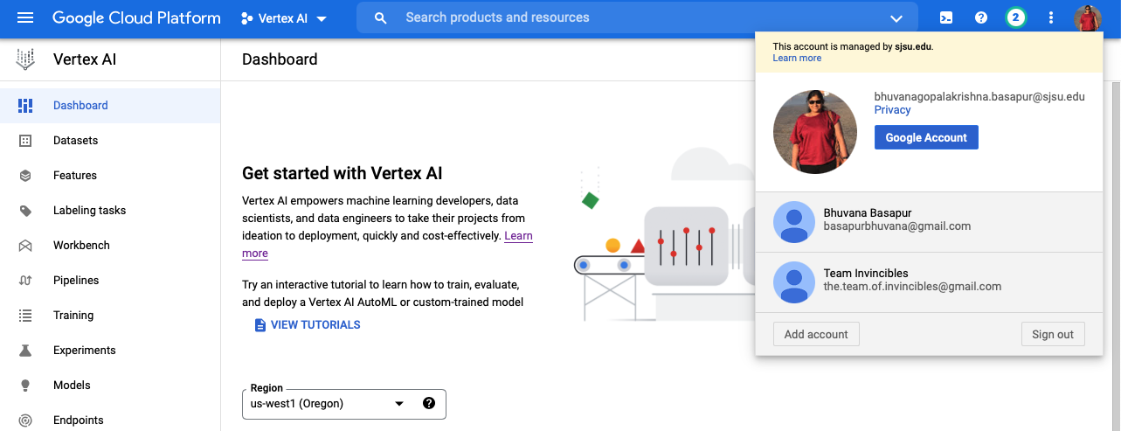

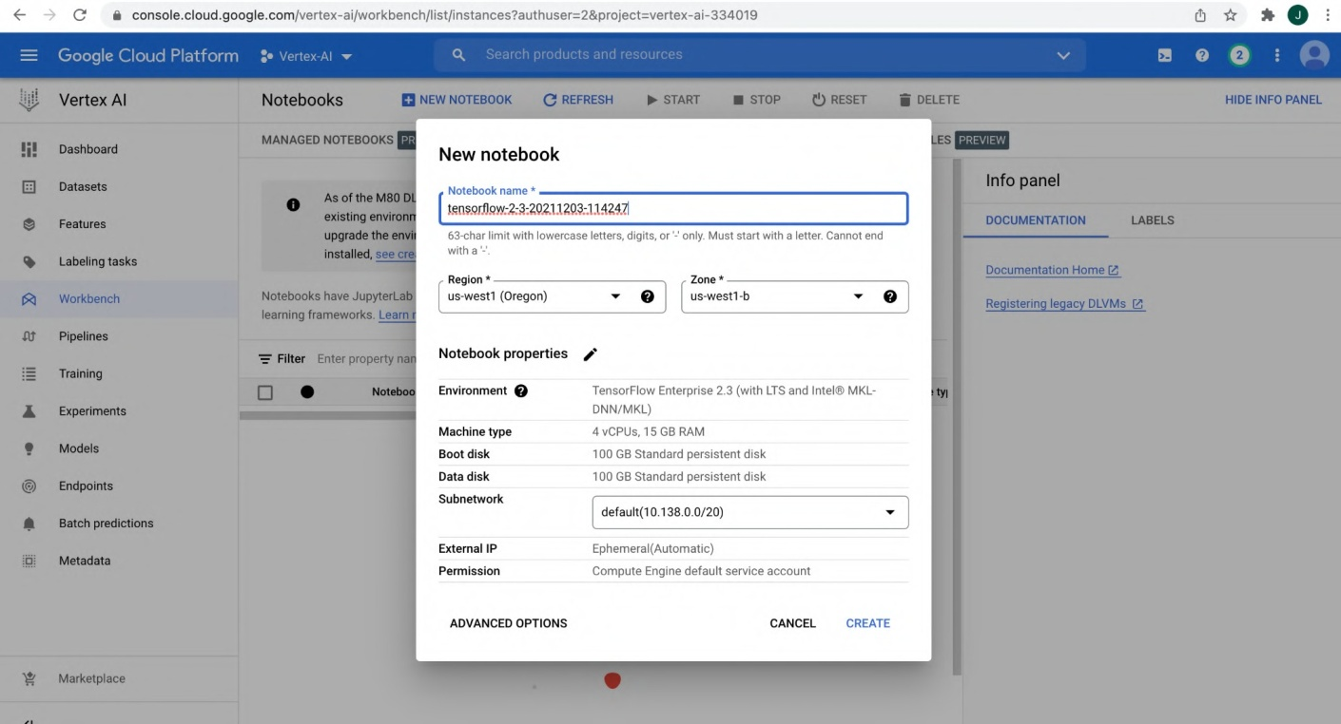

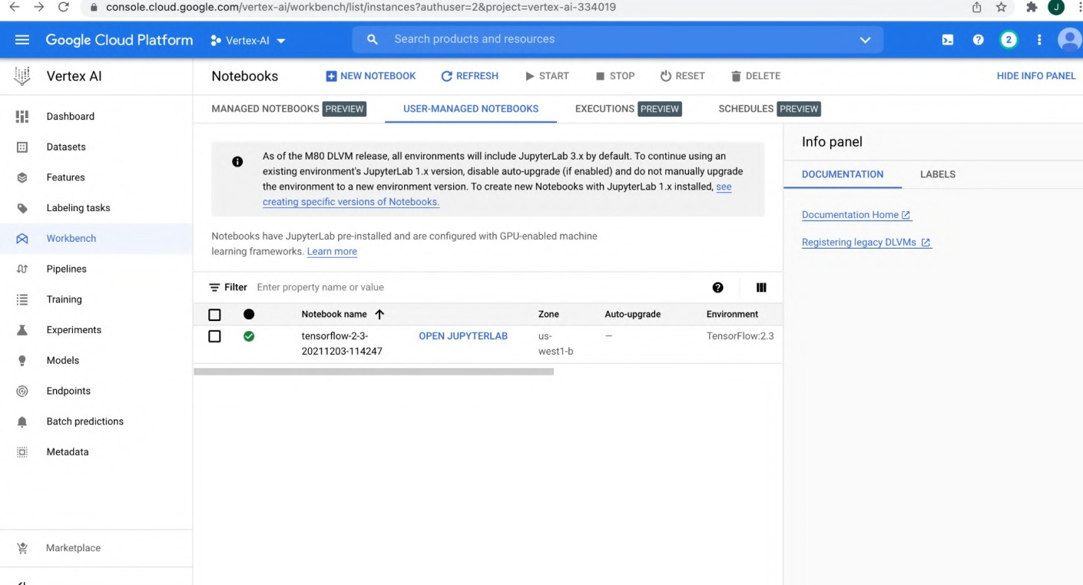

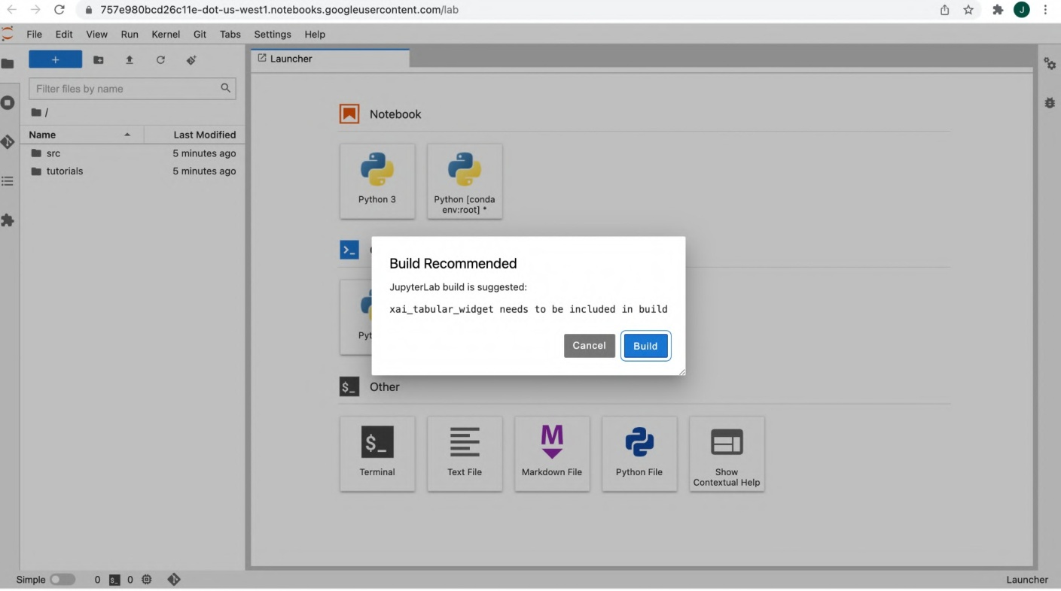

b)

https://codelabs.developers.google.com/vertex-automl-tabular#0

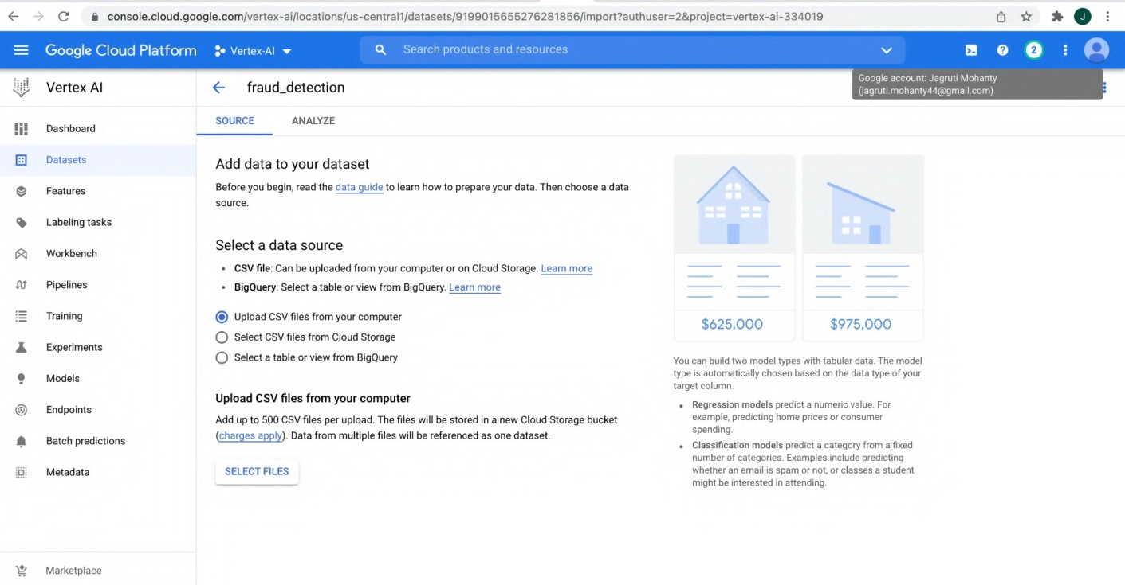



€• C g console.cloud.google.com/vertex- ai/locations/us-central1/datasets/919g0156fi5276281856/import?authuser=2&project=vertex- ai- 334019

Verter AI

•E- fraud_detec1ion

AMALYZfl











e Features



€• —* C a console.cloud.googIe.com/vertex-ai/locations/us-centraI1/datasets/9199o15655276281856/impon?authuser=2&project=vertex-ai-334019

VeMexAl

+

fraud_detection







Add data to your dataset



Select a data source

* CSV file: Can be uploaded from your computer or a Cmd Storage. Learn more



Select CSV files from Cloud Storage

Add up to TOO CSV files per upload. The files will be stored in a new Cloud Storage bucket

. Data from multiple files will be referenced as one dataset.

**AflAñZf**

Add data to your dataset

BeCoreyoubeginread€e +oIe«nâw‹oprepaeyu daaTeañooseadaa

Select a data source

* C6V file: Can be uploaded from your computer or on Cloud Storage. Learn
* BigQuery: '2eIect a table or New from BigQuery. Learn more

O Upload CSV files from your computer Sheet CSV Files from Cloud Storage

@l Sheet a table or view from 8igQuery





Use a BigQuery table or view as your data source. You'll need permission !o access dataset

 

#### 

$625,OOO $97S,0OO





#### 

$625,000 $975,000



Select path

referenced BigQuery table will affect the dataset hefore training.

S o ,o„ow.loud.goog‹e.<om¿ven x-a,ooawons/«s- cn«an¿da ase‹s/e,soo1sossi7oae era a,a;z.°›a«nuse =e&p qe i=vene -a-3a4o,o 



Google Cloud Platform .• vertex-Ai • 

Vertex AI fraud_detection

A NALYZE

Dataset Info 

Created Oec 03, 20?1 11 II All

’ *‘‘’ h ' h ^ i or o i h h 1rei d r1or o r1 n n? K



g Batch predictions

= • • e

" ” ‘*‘*!*  BigQuery type BigQuery mode Missing a f«t› e Disqmm values @ Amount FLOAT NULLAB.E

Class irJTEñER hT ULLAd.E

Time FUA I NULLAd .L

“ " ""”’8'”' VI F LOA I hT ULLAB.L VI 0 FLOAT hlULLAB.E

VII FLOAT NULLAB.E

O C B console.cloud.google.com}vertex-a +/l ocations/ us-central 4 /datasets}919904 SO 55 27G 284 8 56t ana t yze*a u th user=2&project=vertez- at -8 34019

Train new model



fraud_detection_202112319 s457

W ADVANCED OPTIONS







 g console.cloud.google.com/vertex-ai/locations/us-centraI1/datasets/9199015655276 2B1856/anaIyze”authuser= 2&project=vertex-ai- 334019

Train new model

@ Training method @ Model details @ Training options

Enter the maximum number of node hours you wan1 to spend training your model.

You can train for as little as node hour. You may also be eligible to train with free node

@ Compute and pricing

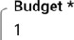

0AflMb

Enable early stopping

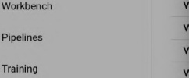



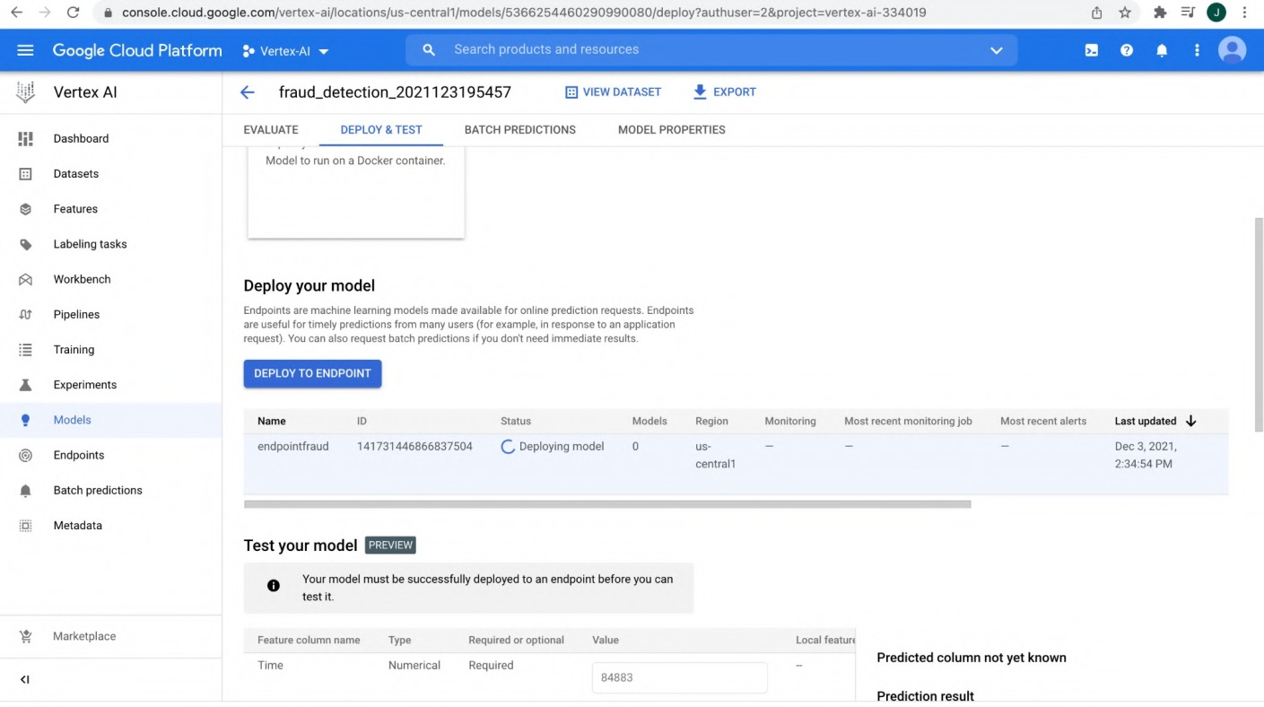

c)

https://codelabs.developers.google.com/vertex_custom_training_prediction#0

(Links to an external site.)

G 0 757e080bzd?6oLe doc us wesñno+ebooksgoogMuseoo1entsomjshw rk pa :}sulo ‹





Persen 1



 Last Modified

QM Notebook

Pytho n 3 





   





Show

C Q 757e980bcd26c11e-doLus-wes|1.no|ebooksgoogleuserconCen|comlab okspasesauo-k/keerip /Do<kerIle 

File Edit View Run Kernel Git Tabs 8etting s HeI p

### X



Dockerf il e

Name - Last Modified 

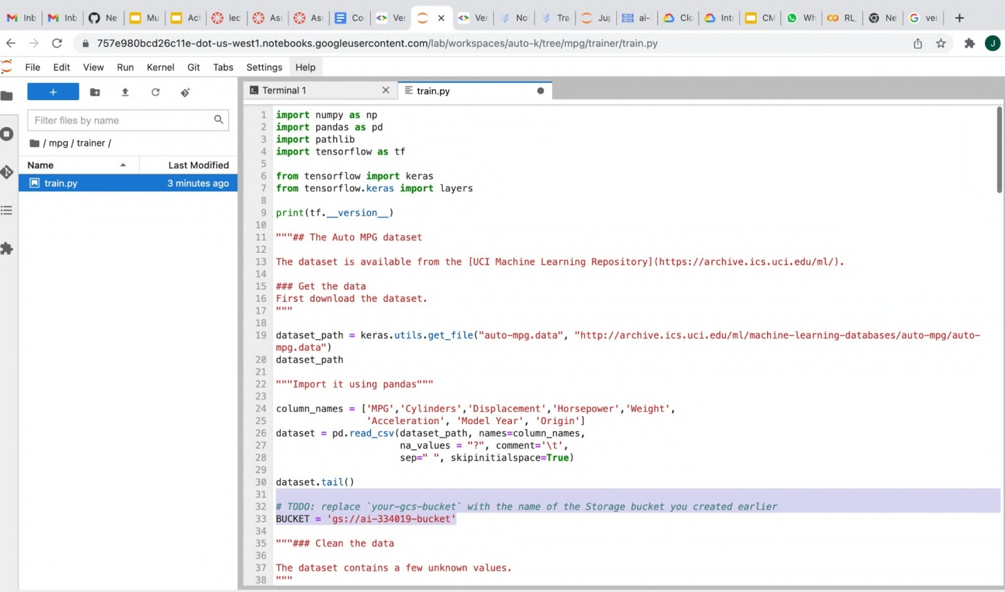

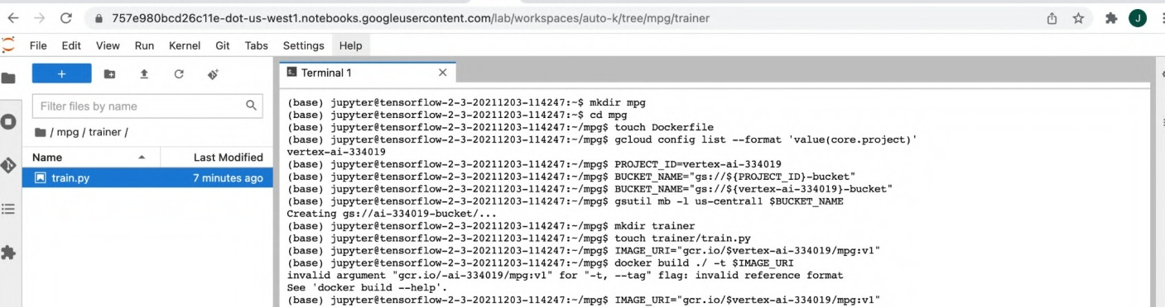

1. Big query :

https://codelabs.developers.google.com/vertex-workbench-intro#0

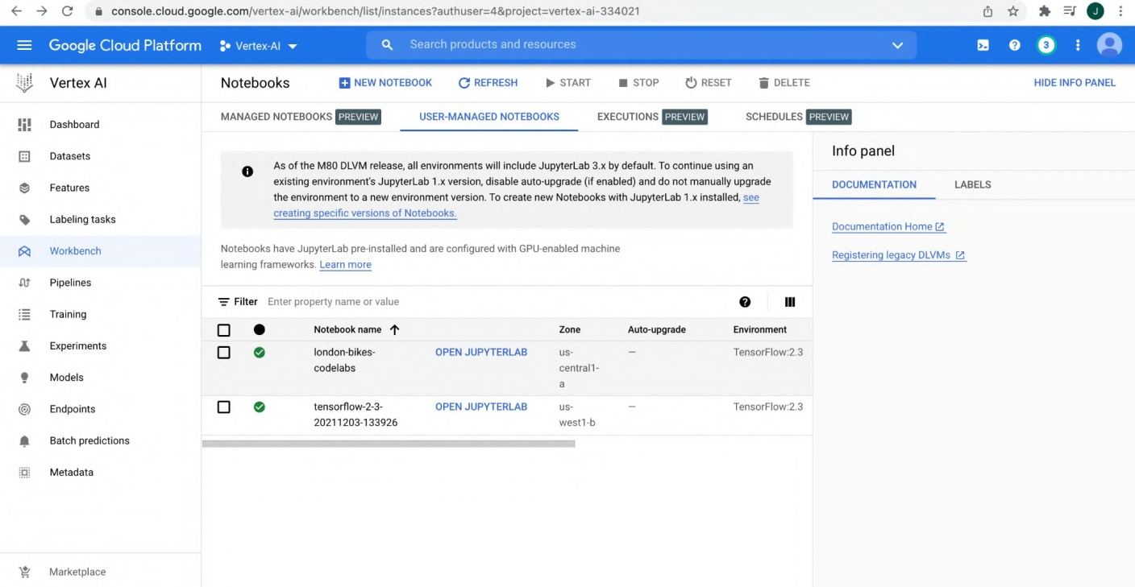

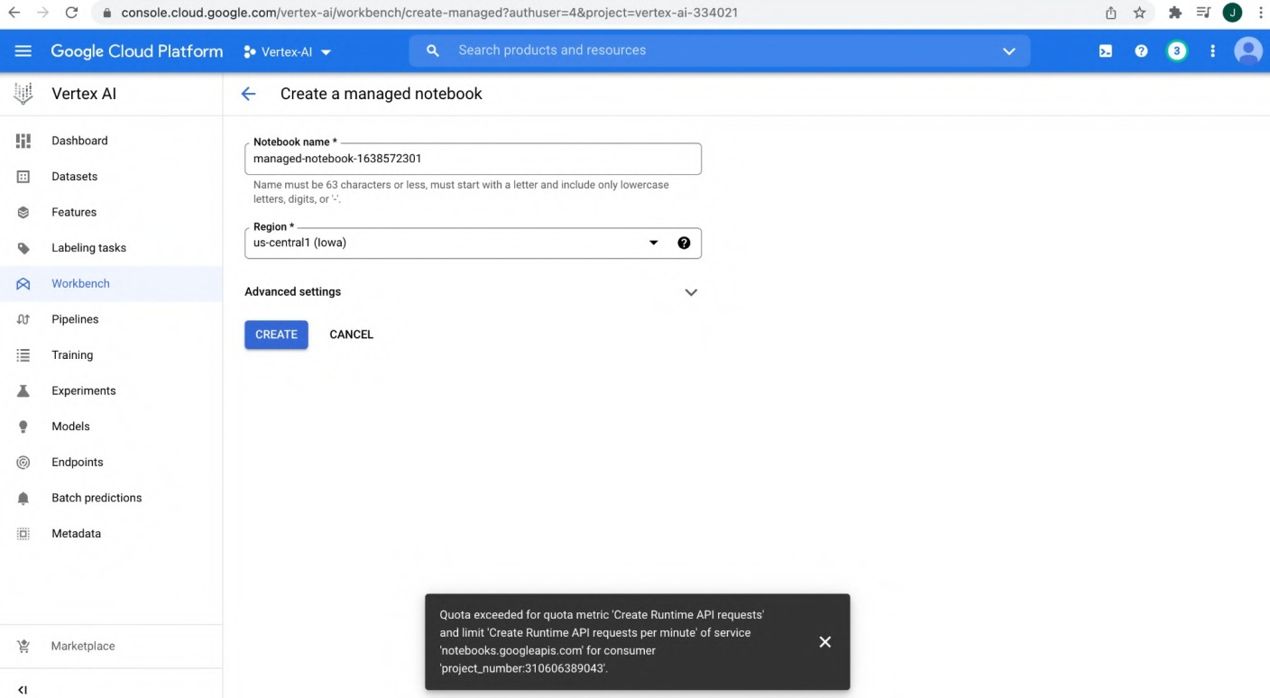

## https://codelabs.developers.google.com/vertex_hyperparameter_tuning#0

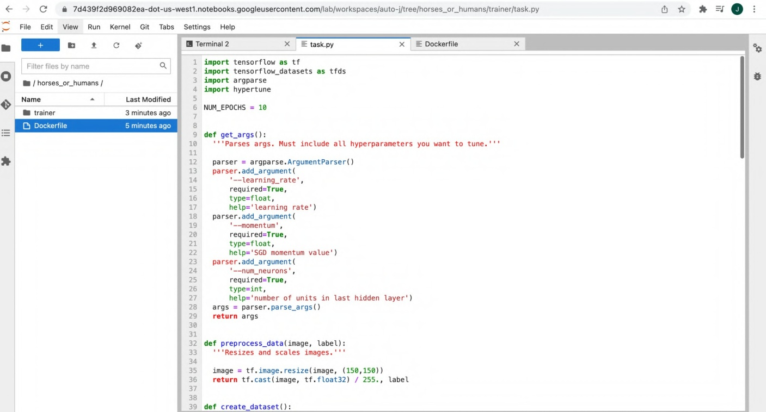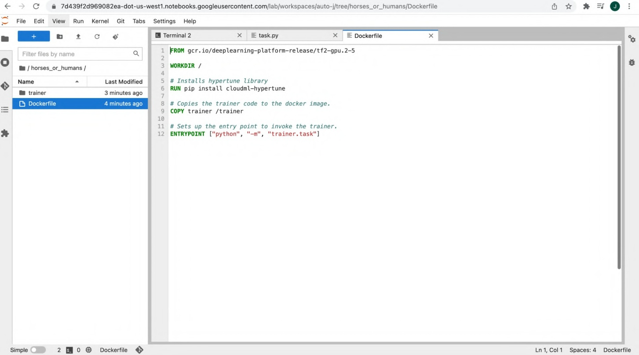

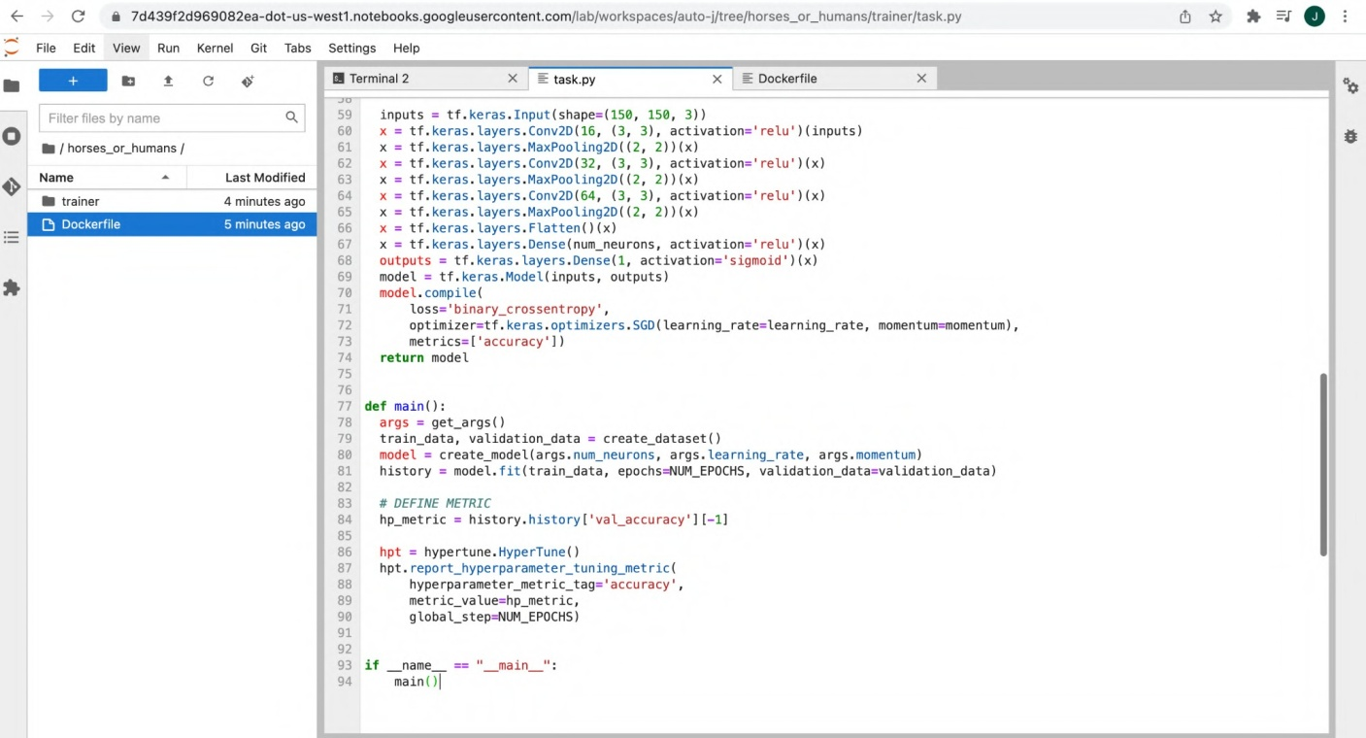

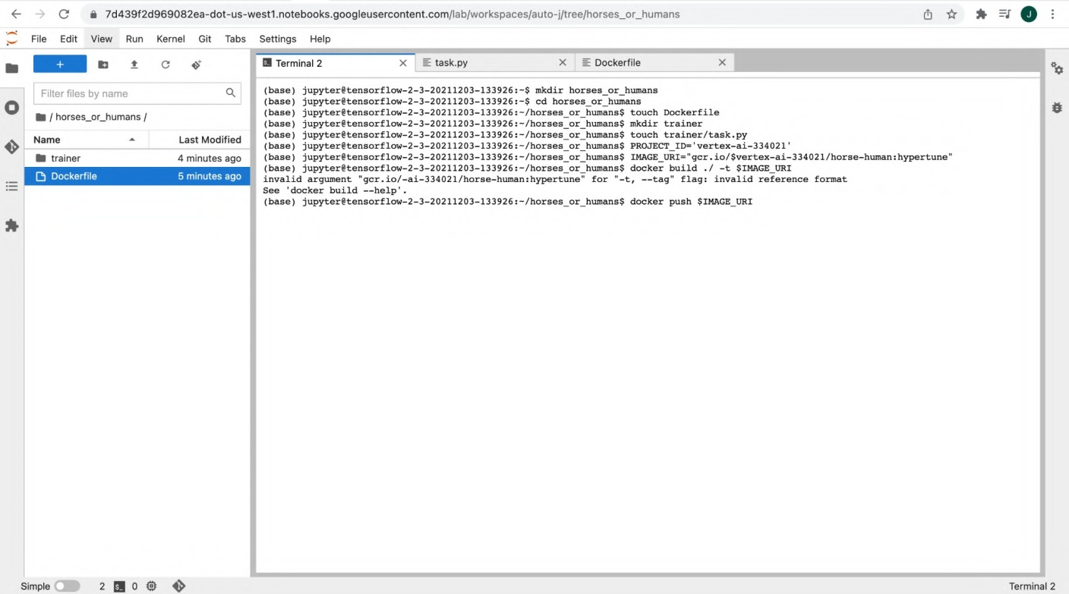

1. https://codelabs.developers.google.com/vertex-mlmd-pipelines#0



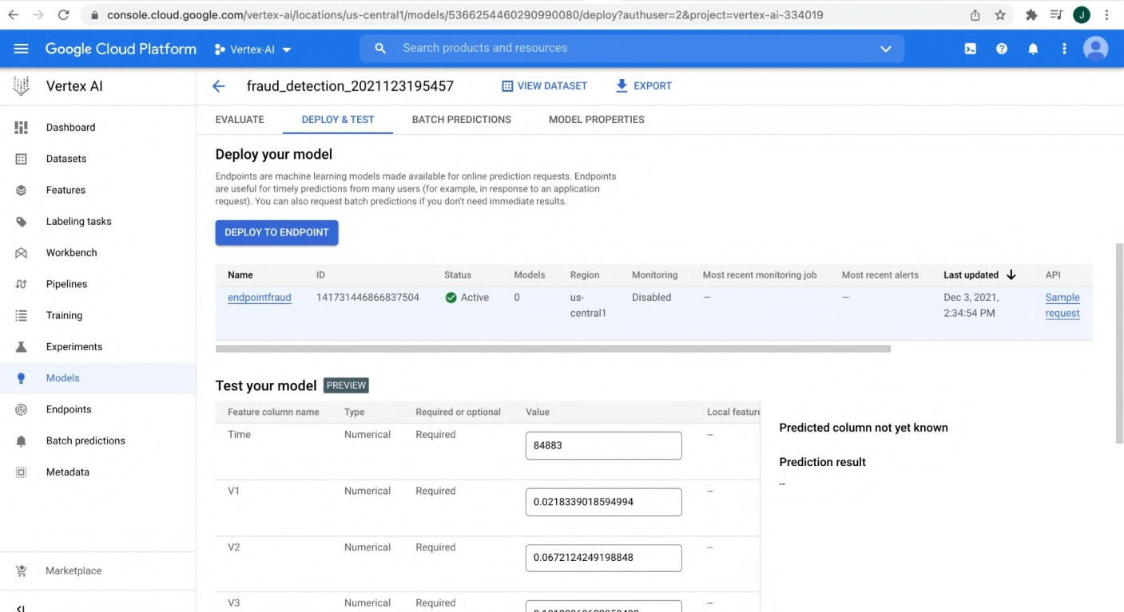

1. https://codelabs.developers.google.com/codelabs/automl-forecasting-with-vertex-ai#0

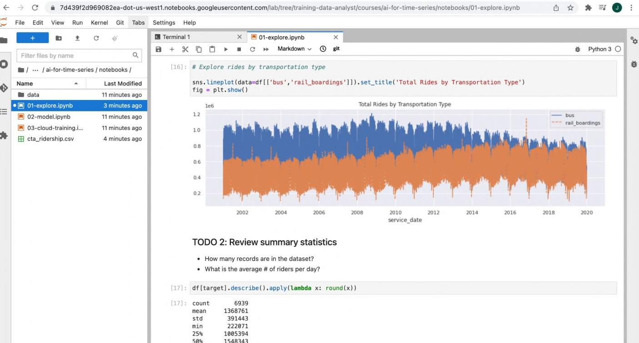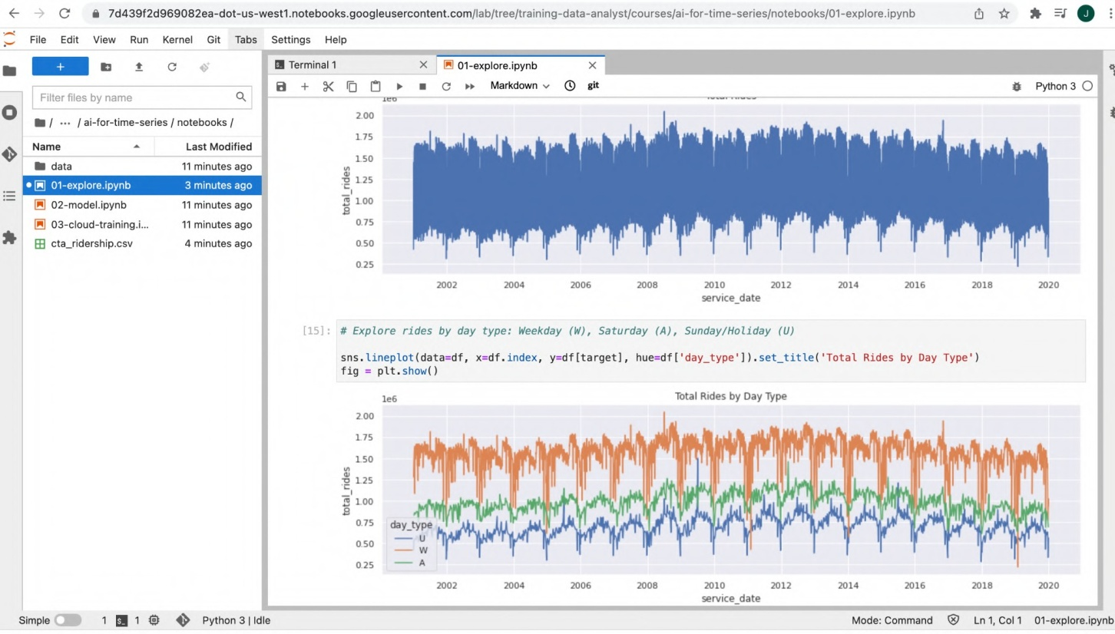

G é 7d4fl9I?d96908?ea-donus-west.no+ebooksgoogIeuserconientcom/abjr e,'waiing-dna-anas ouwu \idor-liu«ri 'uo+ book\O4-Score.p ab 

_ fe Edit View Ru Kerel Gis labs Ss4ings Help

 RTermia4 X ñJbe,Qoe.ipab x

min 222071

Name - Last Modified

' /8 02- mod .°1. +p ynb 

###### 

TODO 3: Explore seasonality

* + Is there much difference between months*
  + can you extract the trend and seasonal pattern from the datas

d ay s o free k = d I . ndex . to se r ze s ( ) . d I . da y ofree k

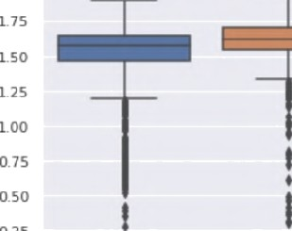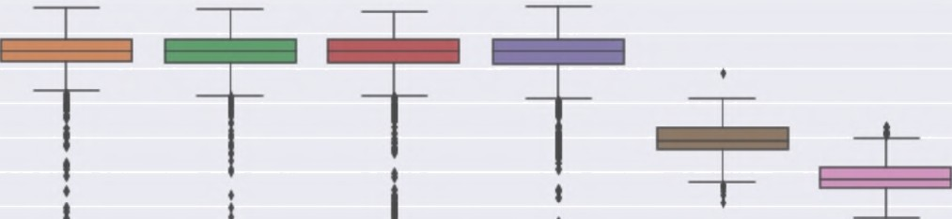

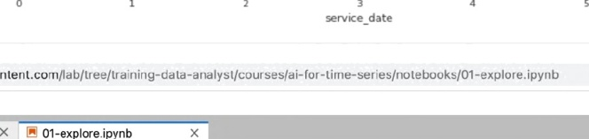File Edit View Run Kernel G it Tabs Se ttings Help

’e

«meseries}xébooñ,' fo fe %s:ridnios of vales far eat svrh » s bo piñ:

moths = d .nde to_series).d:.nook

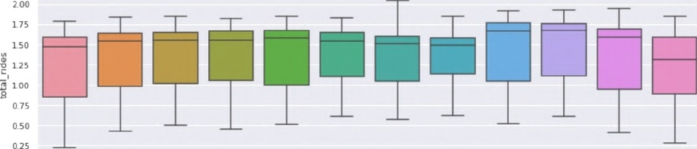W 02-model.i ab 

FB cta ridership.csv 

reññ = seasonal de omyse{d[arge), perisd=3f

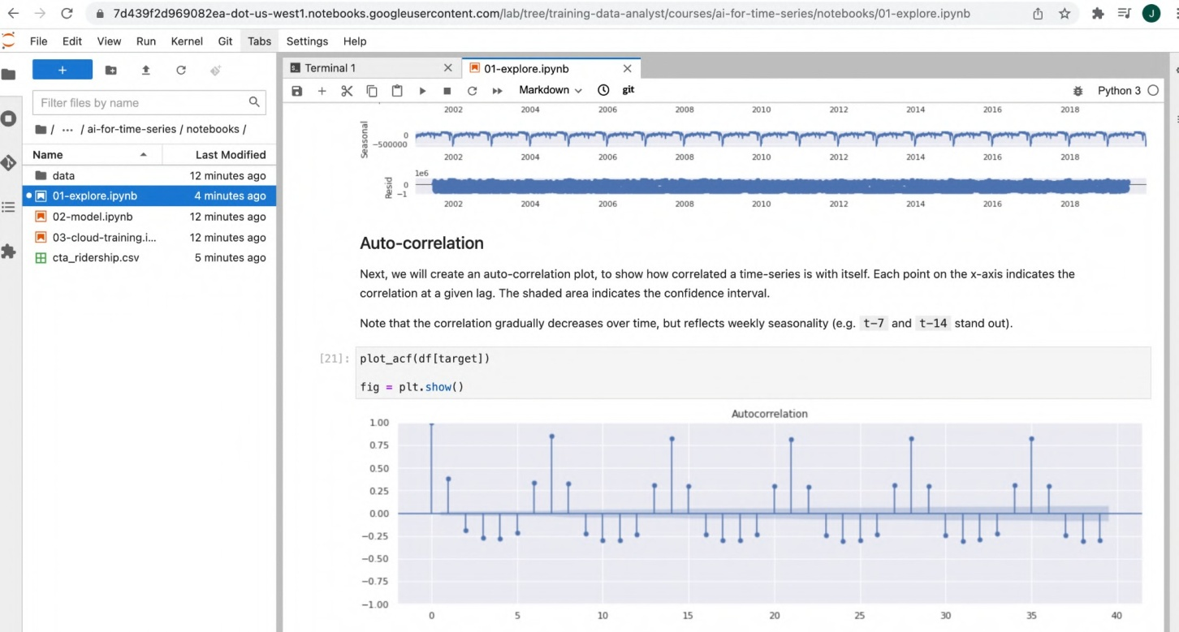

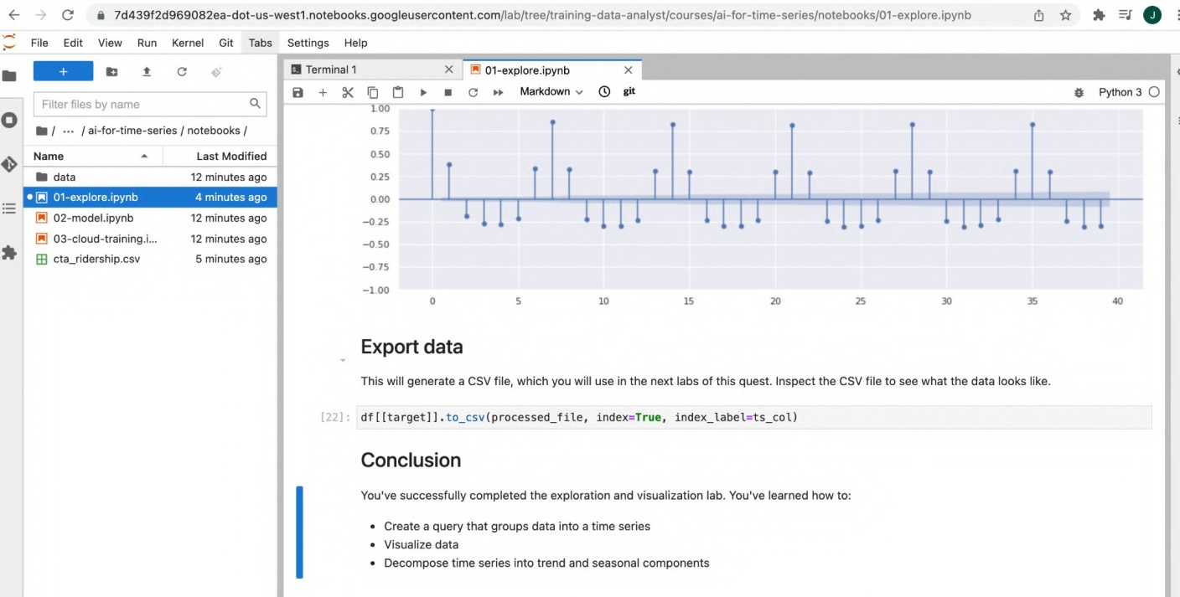

## https://codelabs.developers.google.com/vertex_multiworker_training#0



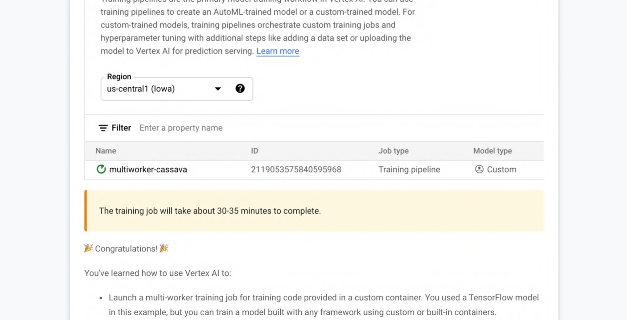

1. https://codelabs.developers.google.com/codelabs/bqml-vertex-prediction#0

training pipelines to create an AutoML-trained model or a custom-trained model. For custom-trained models, training pipelines orchestrate custom training jobs and hyperparameter tuning with additional steps like adding a data set or uploading the model to Vertex AI for prediction serving. Learn more

Region

us-centraI1 (Iowa) 

Filter Enter a property name

Name

j multiworker-cassava

ID

2119053575840595968

Job type

Training pipeline

Model type

@ CUStOft\

The training job will take about 30-35 minutes to complete.

@ Congratulations! 6

You've learned how to use Vertex AI to:

* + Launch a multi-worker training job for training code provided in a custom container. You used a TensorFlow model in this example, but you can train a model built with any framework using custom or built-in containers.

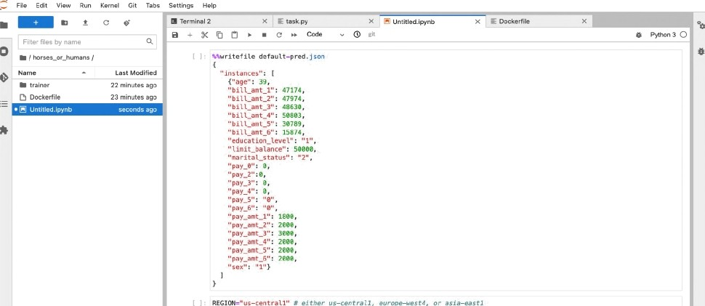+ C g 7d439f2d9690B2ea-dot-us- wes\1.notebooks.soo9Ieusercontent.com/lab/worksPaces/auto-i/ tree/horses_or_humans/Untitled.ipynb

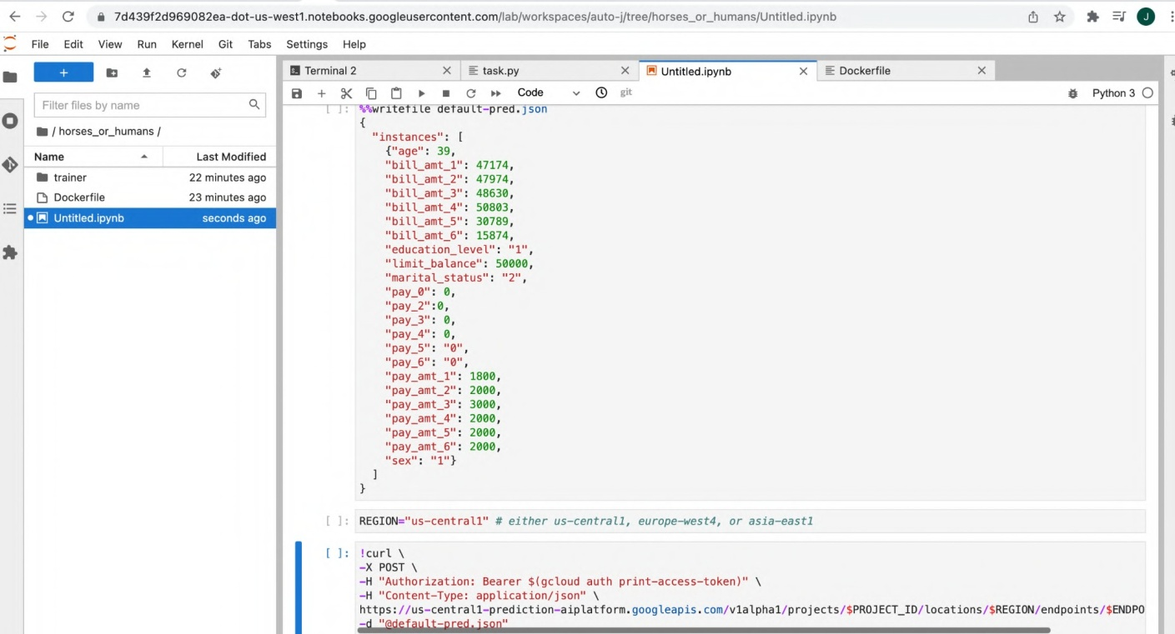

# https://codelabs.developers.google.com/vertexx-xgb-wit#0

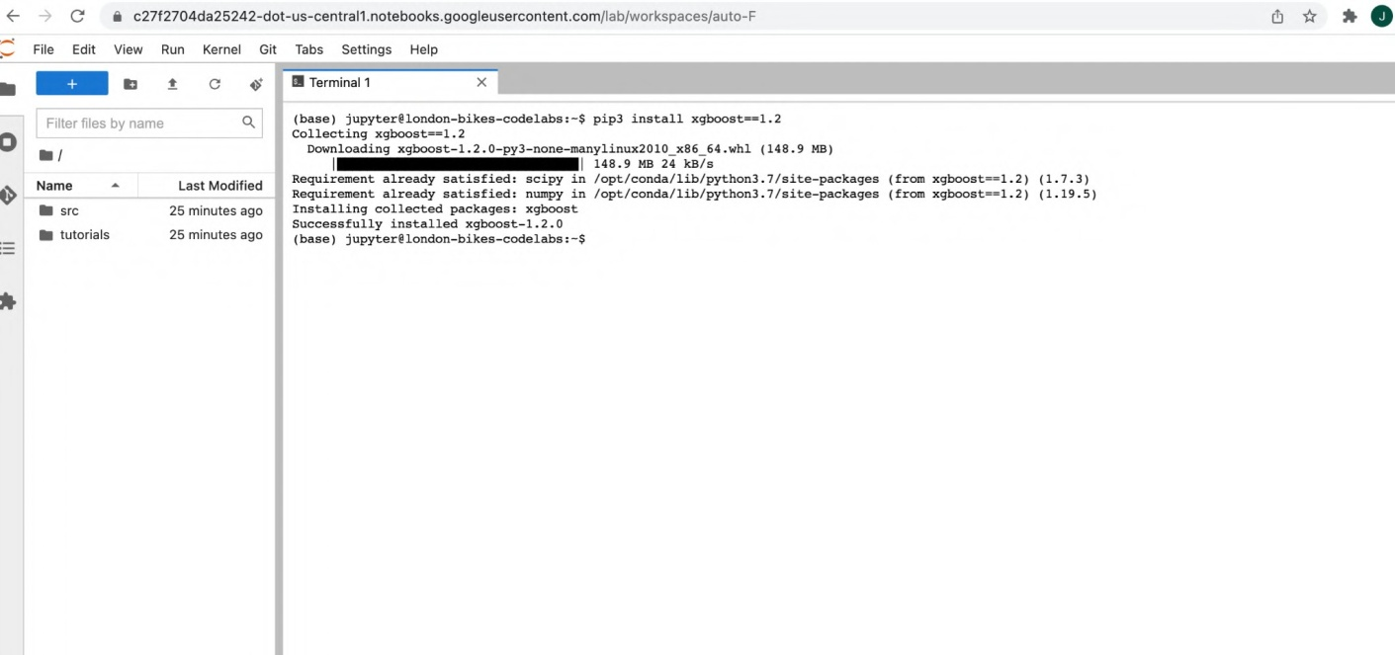

g c27f2704da25242-dot- us- centraI1.notebooks.googIeusercontent.com /Iab/Tree/e ntitled.ipynb 





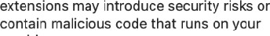

 f rom with/tdg et . no tebo ok . v zsua ”-I z a I No n ?mpo rt WTtW id get , III Co n f zgBu i Ide r

cocuru mAmzs = cone<‹io»s.ordeceJoi<‹(‹



G a cz7fz7o4dazsz4:z-dot-us-central1.notebooks.googieusercontent.com,’lau/i‹ee/ui titieu ipyou  rile Edit view Ran kernel cii cabs sewings i-Jelp

” review' t hird-par/ y*exiensions, and”»me“’

extensions may introduce security' risks cr



data = pd . rea d c s v(

W g c27f27 04da 25242-dot-u s—centraI1. notebooks.googleuserco n tenI.c om,’ia b/l ree/U ntitle d.ipynb 

ri|e Ewe yiez Fun Kerne| sir Rao› stings neip



O^ Untitled.ipyr b



extension community. Howe\’er we do not





prun I ( da ta [ ’ a pp ro v ed ’ ] . va T ue coun- s ( ) )

as=yar o u#aa loanamq=«sa=s =u=¿‹»e app isan_ nome_i ousa s g Pm aion me me°n amp ome iras¿n «

2016 10 0 0 127 0 70.0 2422 0

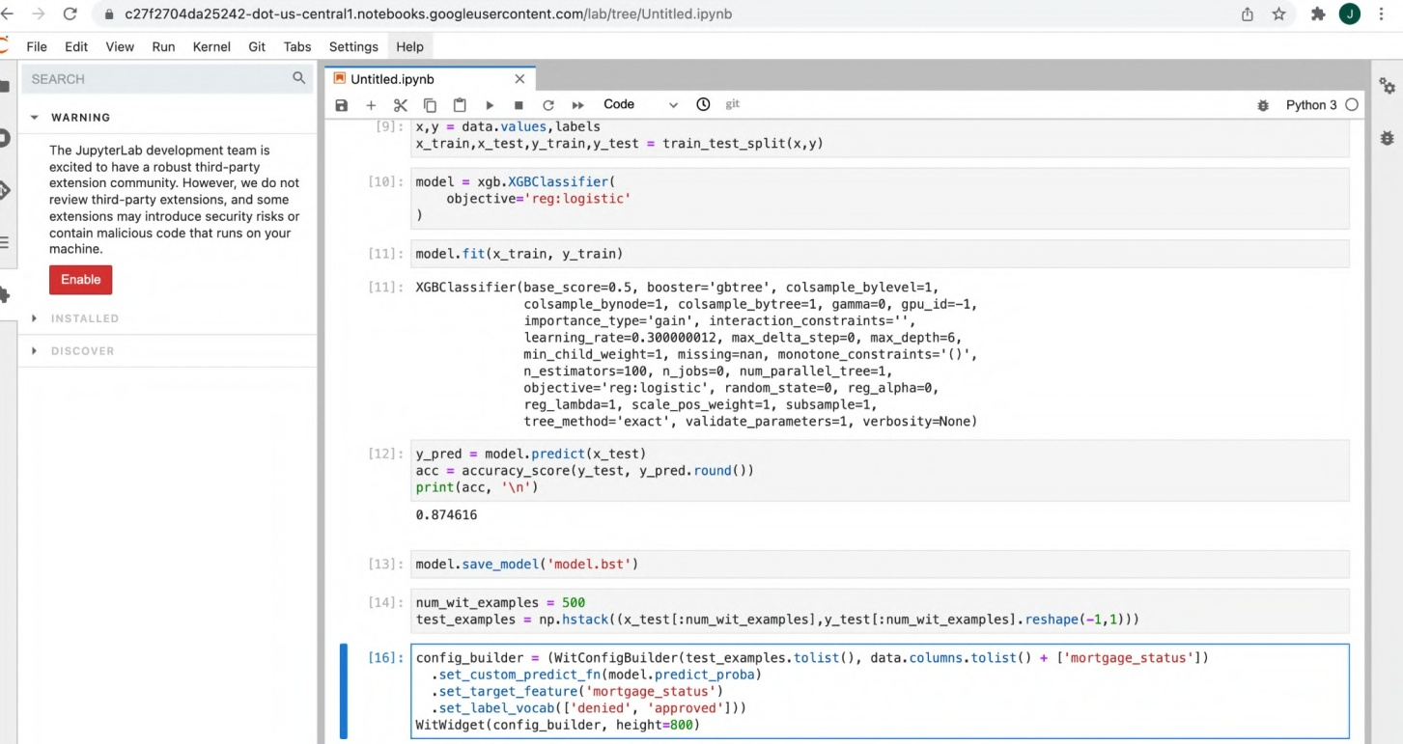

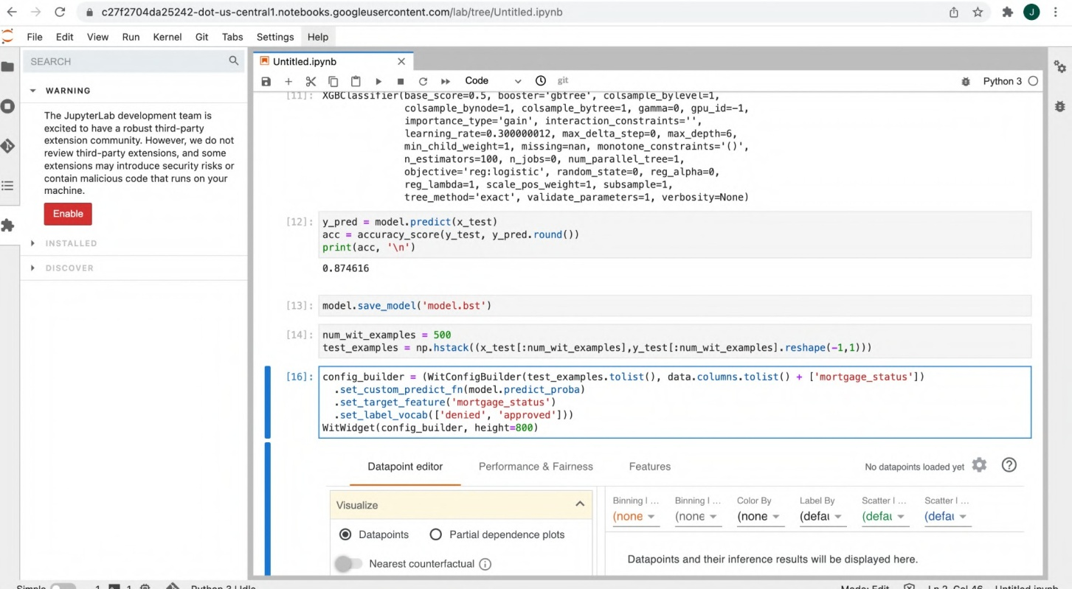

# h ttps://codelabs.developers.google.com/vertex_notebook_executor#0

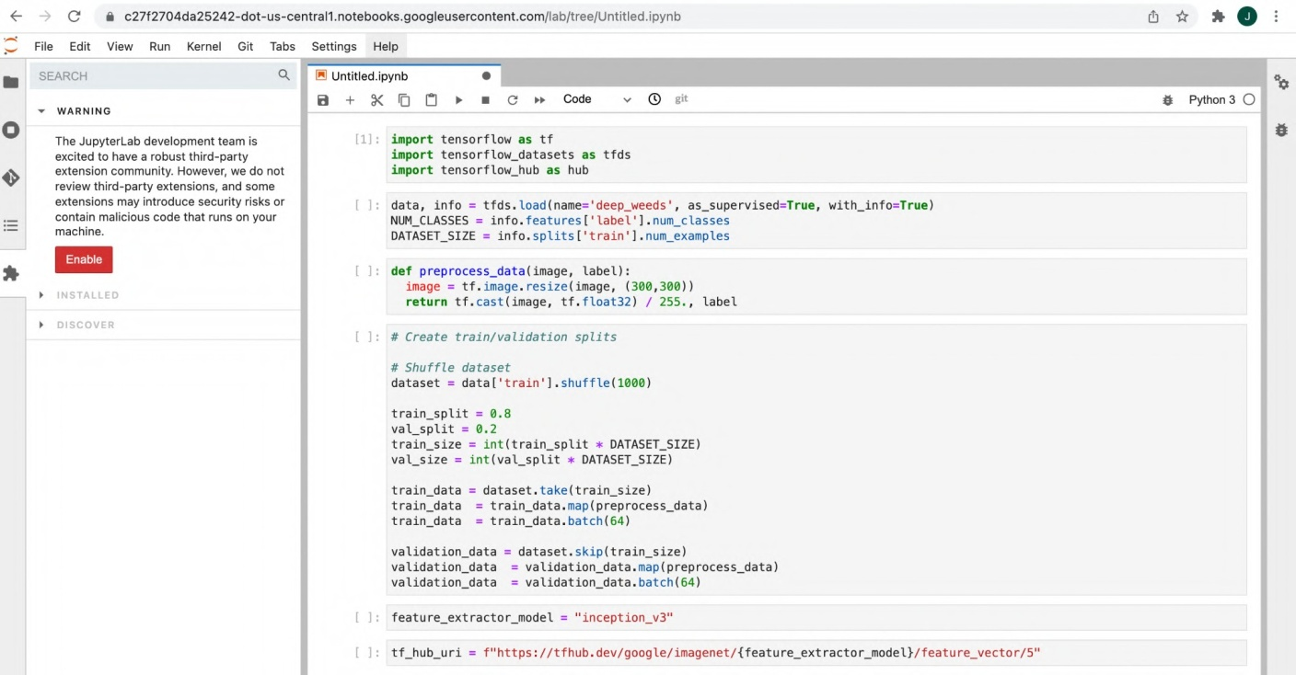

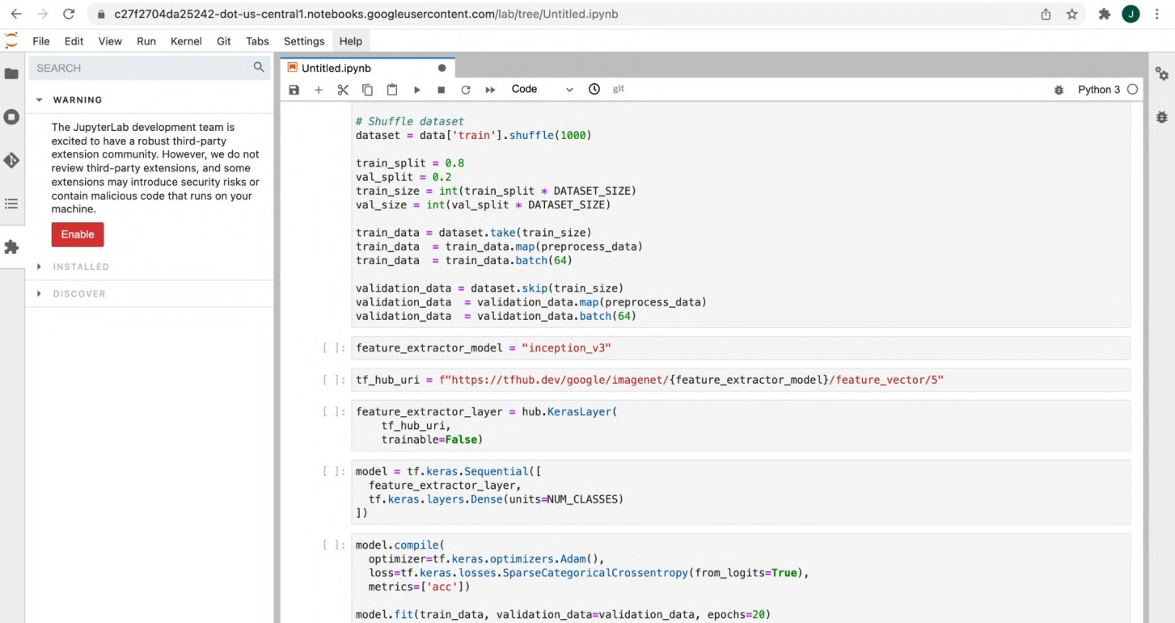

1. h ttps://codelabs.developers.google.com/codelabs/time-series-forecasting-with-cloud-

ai-platform#0

+ C a zd4a9fzduavou yea dot us—west1.notebooks.googIeusercontent.com/lab 

File Edit Vi°.a' Run Kernel Glt Tab s Settin gs Help



 Last Modified

remote: Covn‹iag objects: 100› ñ J?d), done. remote: conpre s ng objects: io0i ‹z4;,z4s), aunt.

 

 g 7 d 439f2d 96g08 2 ea— dot— u-s we st1.noteb ooks.goog ieu• ercontent.com/ ah/t •c c/t -a in i n g- dn t-a a n a I y st/c au -s c sys i fo r ti igg c ° c r ie s/n o tc b oo k s70-J c x p I c re i py rib



 

hestarting the kern el may be reguired to use new packages. Up zp i ns ta I T U sI at : mo deIs : c i kit tea rn u se r



Re qu T renenI aI rea d / s a I is f ze d i sI aI smod e Is T n / opt,‘c anda/1 Tb/ pyt hon3 . 7 / s It e-pa ckage s { 0 . T 3. 1)

$ Python 3

Requirement already safislied: lumpy›-I.?? in /opI/cznta lib/pyIhsn1. /siie—pa<bages (Irsm sIaIsmodeIs) (I.I9.1}

Requ1FenenI al ready sa r is feed : s zx in /opt/conday I.b,’pyt non3. 7/sPte-pac kages ( I ran pat sy>=0. 5 . 2—>stat smodeI s ) 1. T6. 0) Note: you fray need I a rest a rt I he ke rnel to use updated aac kages .

Import libraries and define constants



G » 7d439I?d9690B2ea-doc-us-we›O.nol«bookigooj«usevonenl. omjab4r Qirunng-H+u-añI;u¿ url s,'a-é -no- =e /nn‹bookjO -spa r p b 



^ 01-exp lore.ipyn b

 X

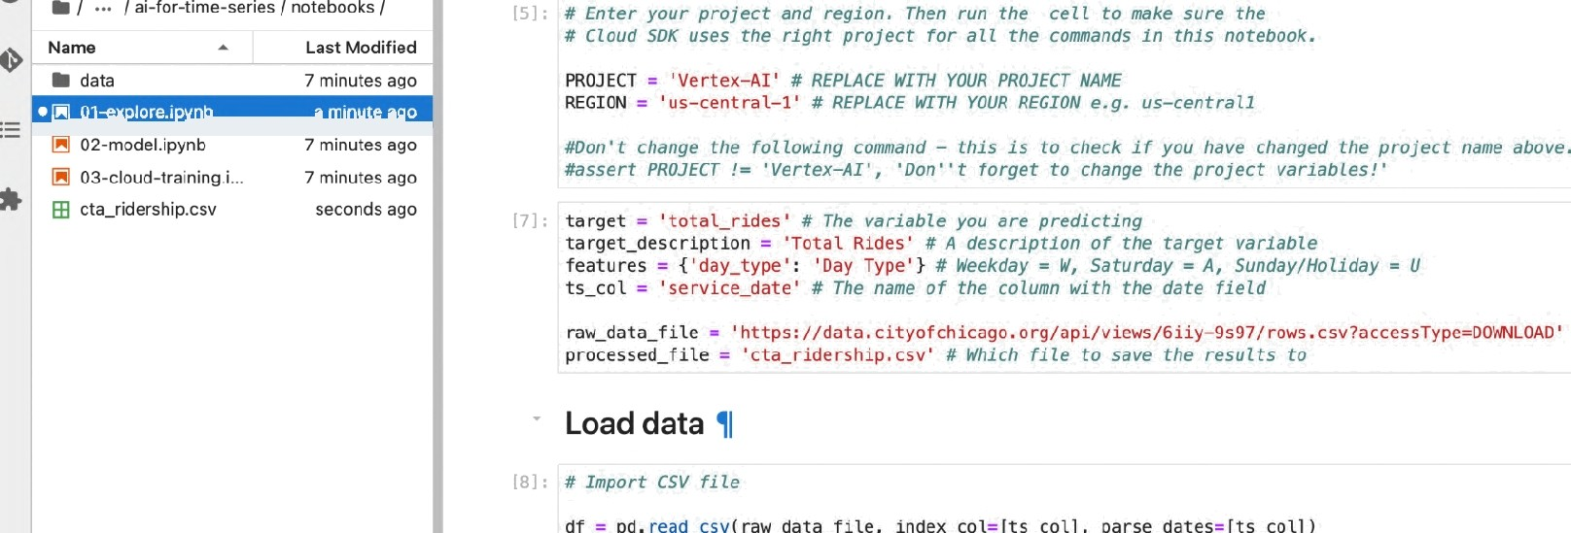

df — dI I dI . index < ’ 202 9- 0 T -0 T ' ]

dI = dI . d r op_d u p T ie a I e s ( )

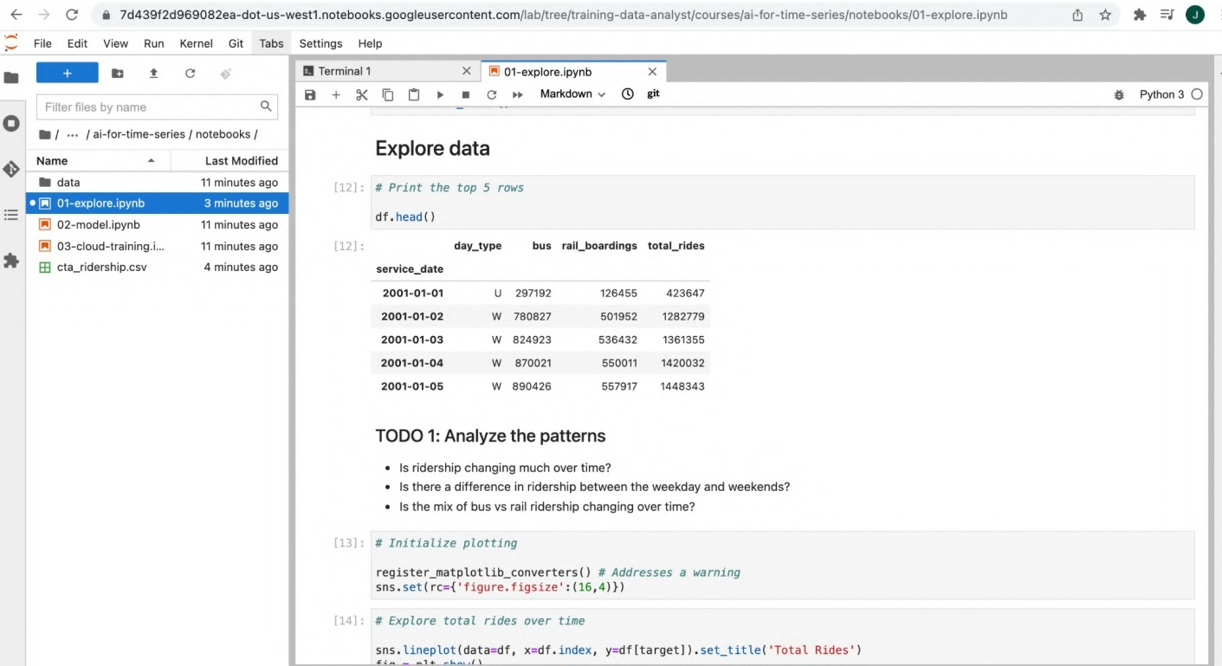

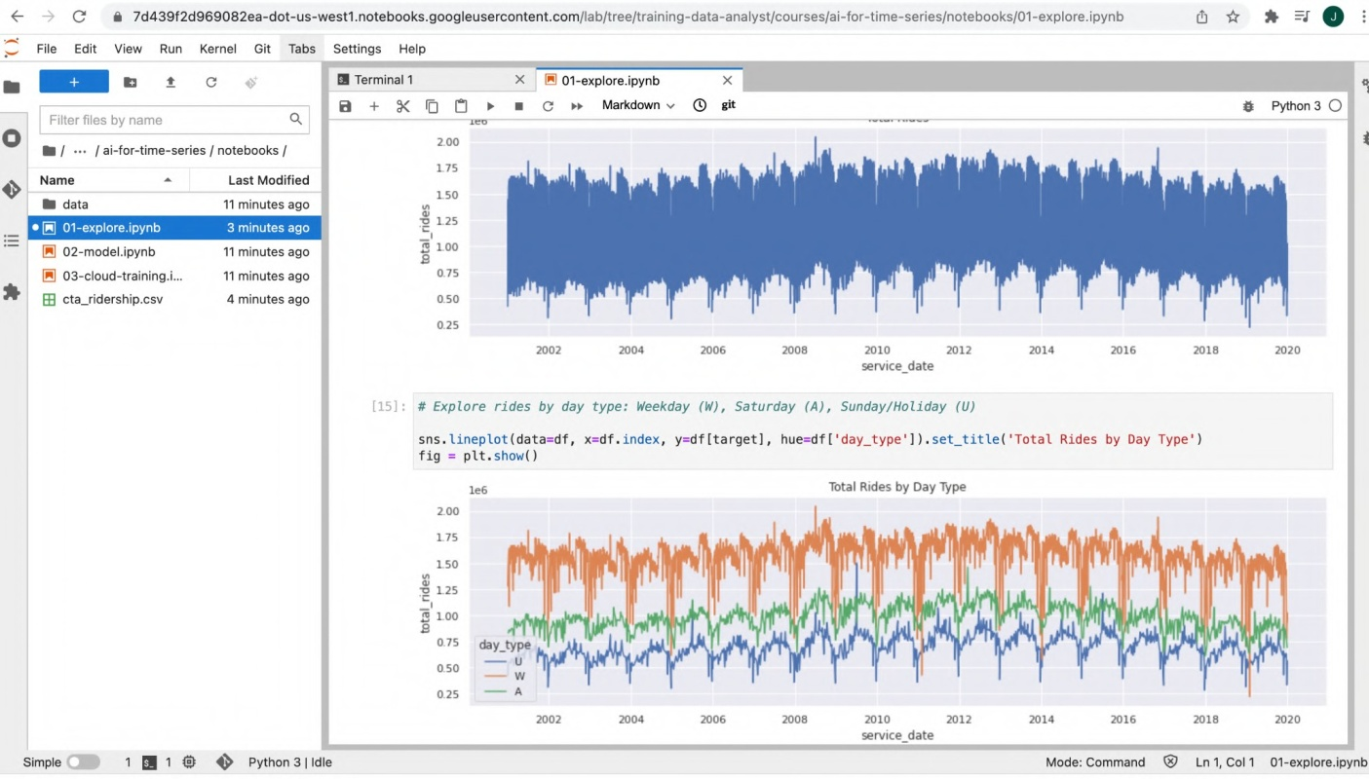

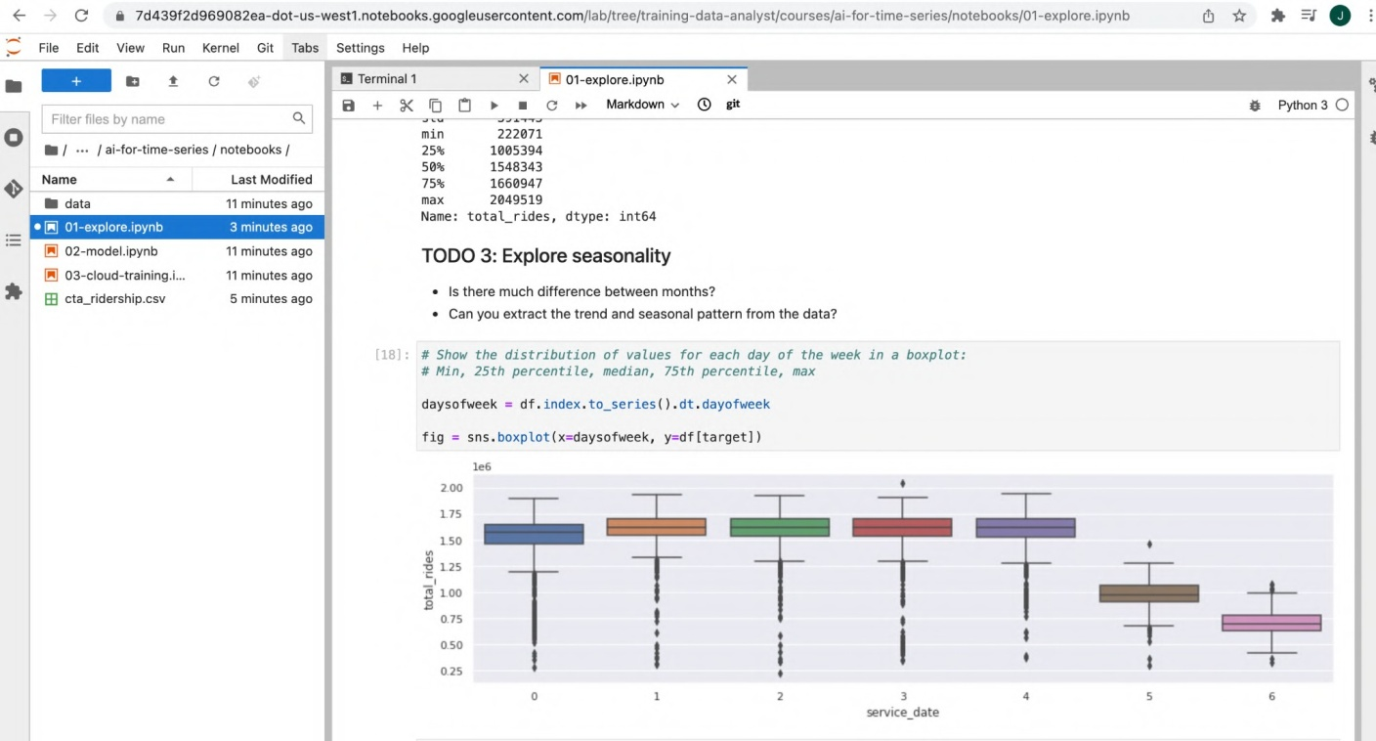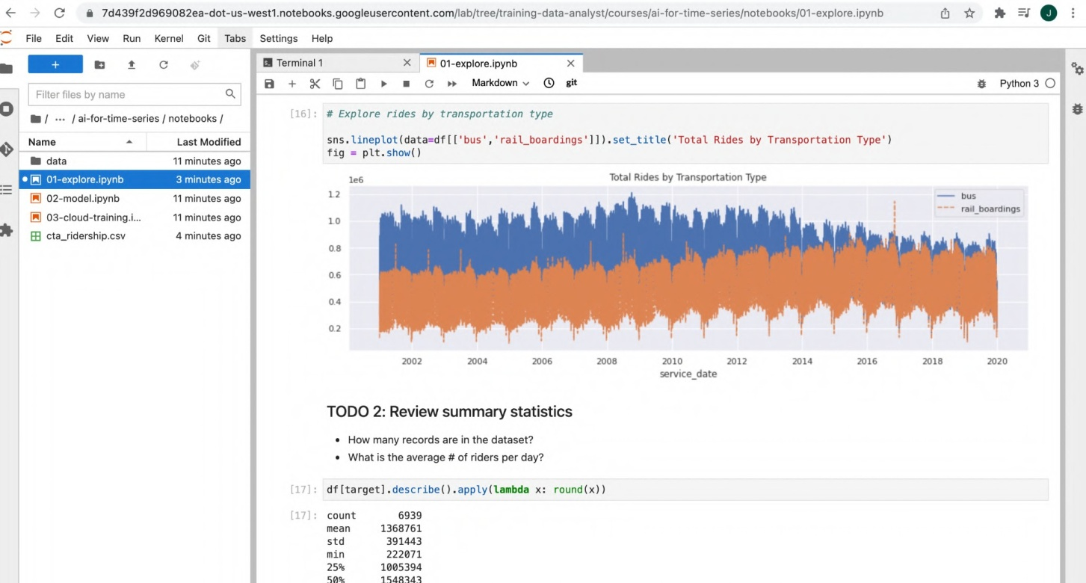

File Edit View Run Kernel Git Tabs Se ttings Help

##### ’e

«meseries}xébooñ,' fo fe %s:ridnios of vales far eat svrh » s bo piñ:

moths = d .nde to_series).d:.nook

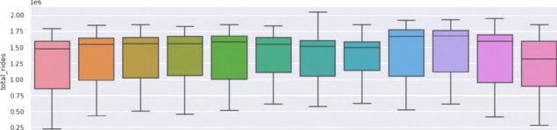W 02-model.i ab

FB cta ridership.csv 

reññ = seasonal de omyse{d[arge), perisd=3f



